**Address of Operator**:

* It is denoted by &.
* When we use it on a variable C++ shows the hexadecimal address of it.
* Only exception is **character** variables. It prints the character even if we write the address of operator. (This happens due to operator overloading, Cout has this logic that if it gets a character variable address it still prints the character.)
* One way to solve this, we can type cast it to (void*). It is a bit of hack as we explicitly tell Cout that the address is not of a character type.

**Dereferencing Operator:**

* It is denoted by *, it can be used for multiplication and declaration of pointer as well.
* By dereferencing a pointer, we can access the variable in which they are pointing to.

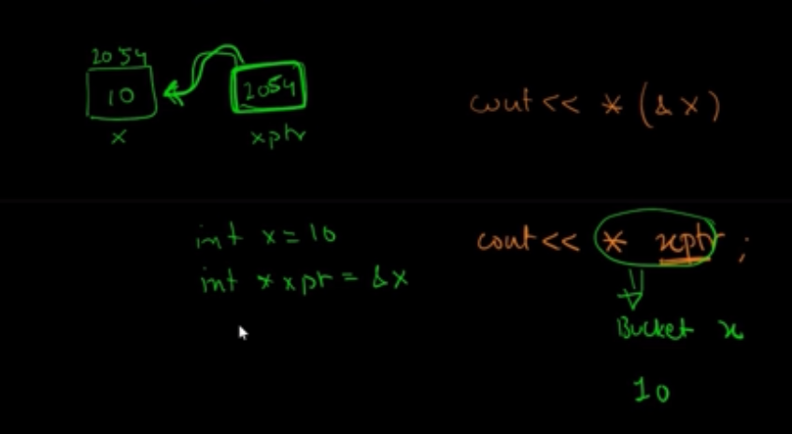

**We can make combination of * and & with pointer to have interesting operations (do some exercise time to time for practice remembering)**

**Pointer:**

* Pointer is a variable that stores the address of another variable.
* Format is **Data_type *variable_name**
* Example int *a = &x; (Declaration and assignment)

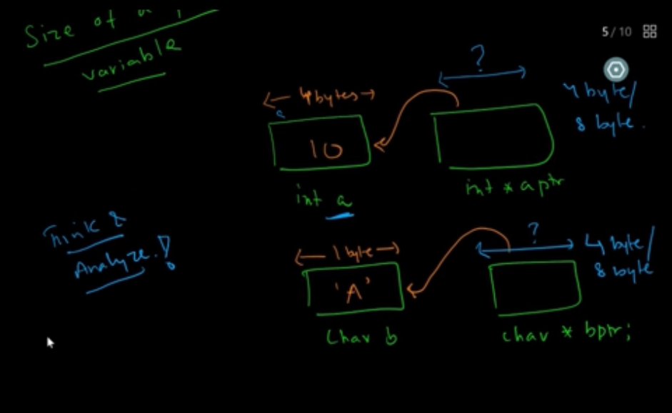

* The size of pointer depends on the system, for example it can be 4-20 bytes in a x86 machine.

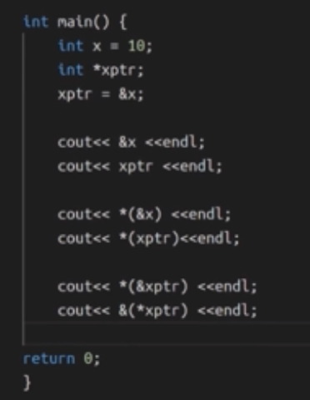

**Pass by reference using pointers:**

